
South Dakota Association of Extension 4-H Professionals
Black Hills Gold & Silver Clover Order Form

Item Price Quantity Total Price
☐ Silver Pin $85.00 Click or tap here to enter text. Click or tap here to enter text.
☐ Silver Pendant $90.00 Click or tap here to enter text. Click or tap here to enter text.
☐ Gold Pin $190.00 Click or tap here to enter text. Click or tap here to enter text.
☐ Gold Pendant $200.00 Click or tap here to enter text. Click or tap here to enter text.

Shipping and Insurance $10.00 1 $10.00

Total Amount Due: Click or tap here to enter text.
Make checks payable to: SDAE4-HP
Allow 3-4 weeks for delivery.

Name: Click or tap here to enter text.
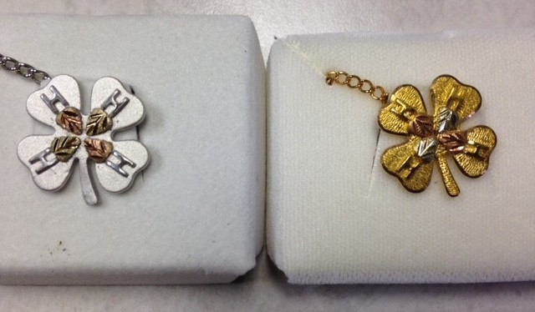
Address: Click or tap here to enter text.
City: Click or tap here to enter text.
State: Click or tap here to enter text.
Zip Code: Click or tap here to enter text.
Phone: Click or tap here to enter text.
Email: Click or tap here to enter text.
Amount Enclosed: Click or tap here to enter text.
Is this a gift?: Click or tap here to enter text.

Return order form to:
SD 4-H Jewelers
1070 3rd St.
Huron, SD 57350
Or email to: john.madison@sdstate.edu

